Lab 001 – Junos CLI, Interfaces, VLAN & Access Ports
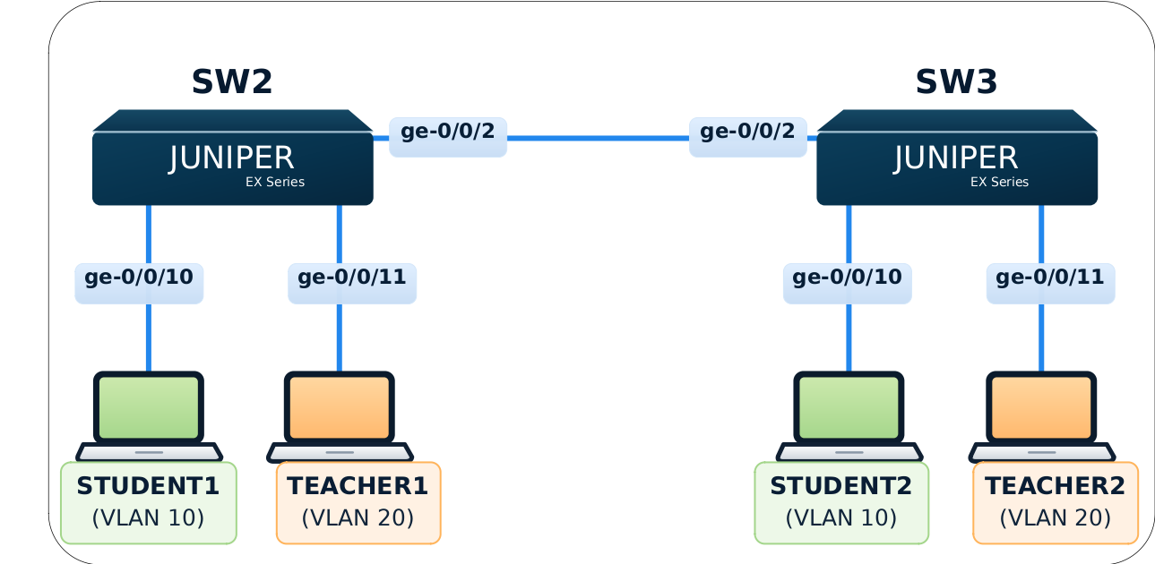

Objective
- Become comfortable with Junos operational and configuration modes.
- Verify physical and logical interface state.
- Understand VLAN membership, access ports and a basic trunk.
- Verify MAC learning and endpoint connectivity.
- Practice safe Junos configuration workflow with compare/commit/rollback.

Tasks
- Access both SW2 and SW3 and identify hostname, model and Junos version.
- Check interface state.
- Confige VLAN Student and Teacher, access and trunk port.
- Demonstrate failed commit for non-existent vlans configuration.
- Demonstrate show | compare and rollback.
- Demonstrate adding more than 1 vlans on access ports.
- Verify VLAN configuration
- Verify the host-facing port is an access port carrying a single VLAN.
- Verify the inter-switch link is a trunk carrying VLAN Student and Teacher.
- Verify MAC learning on both switches.
- Test end-to-end ping on each VLANs.
- Demonstrate removing Teacher VLAN on the trunk port.
- Demonstrate rollback to the previous state.

Guided Steps
- Access both SW2 and SW3 and identify hostname, model and Junos version.
admin@sw2> show version
Hostname: sw2
Model: ex9214
Family: junos
Junos: 25.4R1.12
JUNOS OS Kernel 64-bit [20251024.861cae5_builder_bsd15_254]

................

admin@sw3> show system uptime
Current time: 2026-10-29 03:12:56 UTC
Time Source: LOCAL CLOCK
System booted: 2026-10-29 02:55:52 UTC (00:17:04 ago)
Protocols started: 2026-10-29 02:57:16 UTC (00:15:40 ago)
Last configured: 2026-10-29 02:56:59 UTC (00:15:57 ago) by root
3:12AM up 17 mins, 1 users, load averages: 3.75, 1.69, 0.96

set system time-zone Asia/Jakarta

admin@sw3# run show system uptime
Current time: 2026-10-29 10:13:31 WIB
Time Source: LOCAL CLOCK
System booted: 2026-10-29 09:55:52 WIB (00:17:39 ago)
Protocols started: 2026-10-29 09:57:16 WIB (00:16:15 ago)
Last configured: 2026-10-29 10:13:27 WIB (00:00:04 ago) by admin
10:13AM up 18 mins, 1 users, load averages: 2.95, 1.68, 0.98

admin@sw3> show chassis hardware
Hardware inventory:
Item Version Part number Serial number Description
Chassis VM6AE2B60C6E EX9214
Midplane
Routing Engine 0 RE-VMX
CB 0 VMX SCB
FPC 0 BUILTIN BUILTIN Virtual FPC
CPU Rev. 1.0 RIOT-LITE BUILTIN
MIC 0 Virtual
PIC 0 BUILTIN BUILTIN Virtual

- Check interface state.
admin@sw3> show interfaces ge-0/0/0
Physical interface: ge-0/0/0, Enabled, Physical link is Up
Interface index: 143, SNMP ifIndex: 521
Link-level type: Ethernet, MTU: 1514, LAN-PHY mode, Speed: 1000mbps, BPDU Error: None, Loop Detect PDU Error: None, Ethernet-Switching Error: None,
Remote Bounce: None, MAC-REWRITE Error: None, Loopback: Disabled, Source filtering: Disabled, Flow control: Enabled, Auto-negotiation: Enabled, Remote fault: Online,
Media type: Fiber
Device flags : Present Running
Interface Specific flags: Internal: 0x101200
Interface flags: SNMP-Traps Internal: 0x4000
Link flags : None
CoS queues : 8 supported, 8 maximum usable queues
Current address: 52:54:00:12:34:56, Hardware address: 52:54:00:12:34:56
Last flapped : 2026-10-29 09:57:52 WIB (00:32:34 ago)
Input rate : 0 bps (0 pps)
Output rate : 0 bps (0 pps)
Active alarms : None
Active defects : None
PCS statistics Seconds
Bit errors 0
Errored blocks 0
Interface transmit statistics: Disabled

Logical interface ge-0/0/0.16386 (Index 333) (SNMP ifIndex 545)
Flags: Up SNMP-Traps 0x4004000 Encapsulation: ENET2
Input packets : 0
Output packets: 0

admin@sw3> show interfaces terse | match ge-0/0/1[01]
ge-0/0/10 up up
ge-0/0/10.16386 up up
ge-0/0/11 up up
ge-0/0/11.16386 up up

- Configure VLAN Student and Teacher, access and trunk port.
- Demonstrate failed commit for non-existent vlans configuration.
- Demonstrate show | compare and rollback.
- Demonstrate adding more than 1 vlans on access ports.
admin@sw2> configure
admin@sw3# set interfaces ge-0/0/0 unit 0 family ethernet-switching vlan members Student

[edit]
admin@sw3# commit check
error: In routing-instance default-switch vlan Student configured under interface ge-0/0/0.0 does not exist
error: configuration check-out failed

set vlans Student vlan-id 10
set vlans Teacher vlan-id 20

set interfaces ge-0/0/10 unit 0 family ethernet-switching vlan members Student
set interfaces ge-0/0/11 unit 0 family ethernet-switching vlan members Teacher

set interfaces ge-0/0/2 unit 0 family ethernet-switching interface-mode trunk vlan members [ Student Teacher ]

commit check
commit

admin@sw3# show | compare
[edit interfaces ge-0/0/10 unit 0 family ethernet-switching vlan]
- members Student;
+ members [ Student Teacher ];

[edit]
admin@sw3# commit check
[edit interfaces ge-0/0/10 unit 0 family ethernet-switching]
'vlan'
Access interface can be part of only one vlan
error: configuration check-out failed

- Verify VLAN configuration
- Verify the host-facing port is an access port carrying a single VLAN.
- Verify the inter-switch link is a trunk carrying VLAN Student and Teacher.
admin@sw3> show vlans brief

Routing instance VLAN name Tag Interfaces
default-switch Student 10
ge-0/0/10.0*
ge-0/0/2.0*
default-switch Teacher 20
ge-0/0/11.0*
ge-0/0/2.0*
default-switch default 1

admin@sw3> show vlans 10 detail

Routing instance: default-switch
VLAN Name: Student State: Active
Tag: 10
Internal index: 3, Generation Index: 2, Origin: Static
Mac aging: Enabled
MAC aging time: 300 seconds
Mac-IP-Snooping Enabled : No
VXLAN Enabled : No
Interfaces:
ge-0/0/10.0*,untagged,access
ge-0/0/2.0*,tagged,trunk
Number of interfaces: Tagged 1 , Untagged 1
Total MAC count: 2

admin@sw3> show vlans Teacher detail

Routing instance: default-switch
VLAN Name: Teacher State: Active
Tag: 20
Internal index: 4, Generation Index: 3, Origin: Static
Mac aging: Enabled
MAC aging time: 300 seconds
Mac-IP-Snooping Enabled : No
VXLAN Enabled : No
Interfaces:
ge-0/0/11.0*,untagged,access
ge-0/0/2.0*,tagged,trunk
Number of interfaces: Tagged 1 , Untagged 1
Total MAC count: 2

admin@sw3> show vlans interface ge-0/0/10.0 detail
Vlan Name: Student
Logical Interface: ge-0/0/10.0
VLAN Index: 3 VLAN ID: 10
Generation: 129 Sequence number: 0
VSTP Index: 12 Handle: 0x6830090

admin@sw3> show vlans interface ge-0/0/2.0 detail
Vlan Name: Student
Logical Interface: ge-0/0/2.0
VLAN Index: 3 VLAN ID: 10
Generation: 131 Sequence number: 0
VSTP Index: 4 Handle: 0x6830a90
Vlan Name: Teacher
Logical Interface: ge-0/0/2.0
VLAN Index: 4 VLAN ID: 20
Generation: 132 Sequence number: 0
VSTP Index: 4 Handle: 0x6830f90

- Verify MAC learning on both switches.
- Test end-to-end ping on each VLANs.
- Demonstrate removing Teacher VLAN on the trunk port.
- Demonstrate rollback to the previous state.
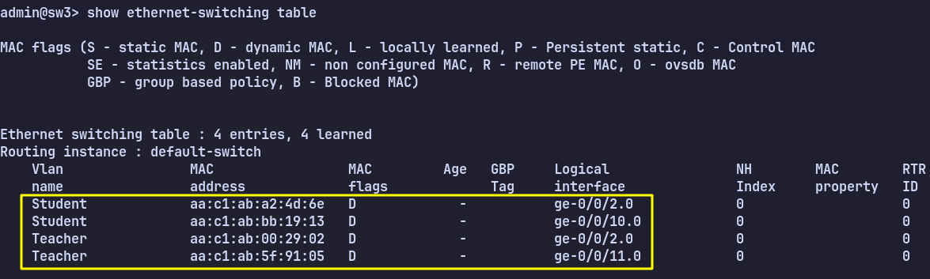

delete interfaces ge-0/0/2 unit 0 family ethernet-switching vlan members Teacher
commit
rollback 1
commit

Lab 002 – LACP
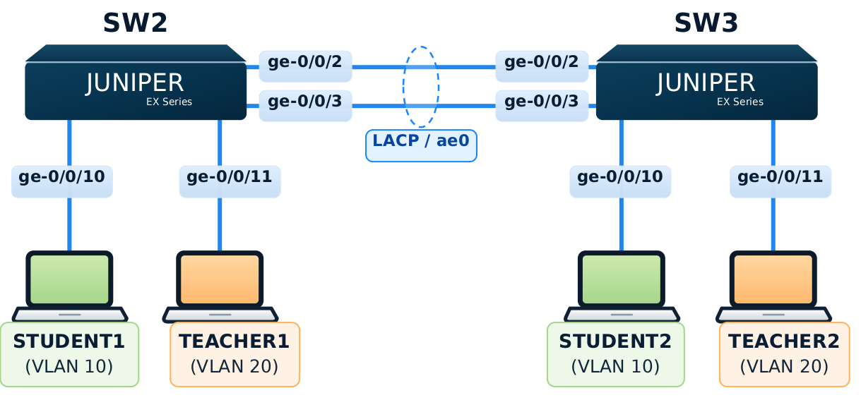

Objective
- Understand how two physical links form one logical AE interface.
- Configure LACP on both switches.
- Verify AE and member-link status.
- Test redundancy by temporarily disabling one member link.

Tasks
- Check the current configuration of ge-0/0/2 and ge-0/0/3 on both switches.
- Configure ae0 on both switches as trunk ports and allow vlan Student and Teacher.
- Demonstrate that without enabling aggregated ethernet support, ae0 isn’t created.
- Enable support for one aggregated Ethernet interface on SW2 and SW3.
- Configure ae0 for the Layer-2 service required by the lab.
- Assign ge-0/0/2 and ge-0/0/3 as its LACP members.
- Verify ae0 and LACP status on both switches.
- Confirm both physical member links are operational and joined to ae0.Temporarily disable one member link. Verify ae0 remains operational through the remaining link.
- Restore the disabled member link and verify both members return to service.
- Check the final configuration with `show | compare`, commit any pending changes, and verify the final state.

Guided Steps
- Check the current configuration of ge-0/0/2 and ge-0/0/3 on both switches.
admin@sw3> show configuration interfaces ge-0/0/2
unit 0 {
family ethernet-switching {
interface-mode trunk;
vlan {
members [ Student Teacher ];
}
}
}

admin@sw3> show configuration interfaces ge-0/0/3

- Configure ae0 on both switches as trunk ports and allow vlan Student and Teacher.
- Configure ae0 for the Layer-2 service required by the lab.
- Demonstrate that without enabling aggregated ethernet support, ae0 isn’t created.
- Enable support for one aggregated Ethernet interface on SW2 and SW3.
# sw2 & sw3

set interfaces ae0 aggregated-ether-options lacp active
set interfaces ae0 unit 0 family ethernet-switching interface-mode trunk
set interfaces ae0 unit 0 family ethernet-switching vlan members [ Student Teacer ]

admin@sw3# run show interfaces ae0 terse
error: device ae0 not found

set chassis aggregated-devices ethernet device-count 1

admin@sw3# run show interfaces ae0 terse
Interface Admin Link Proto Local Remote
ae0 up down

- Assign ge-0/0/2 and ge-0/0/3 as its LACP members.
- Verify ae0 and LACP status on both switches.

